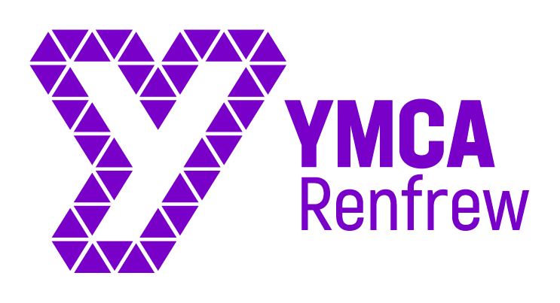

Background on Renfrew YMCA
Renfrew YMCA is a Christian, third sector youth work organisation who work with children and young people from across Renfrew and its surrounding areas, primarily aged from 0 years old to 24 years old, though early intervention projects and service provision for community issues. We work with all children and young people breaking down barriers in the community and building positive relaionships with other community members and supporting thm to reach their full potential though needs led strategies.
We run a wide range of activities that include mentoring, centre-based drop-ins, outdoor learning activities and young leader development.

Job Profile

JOB TITLE | Youth and Community Development Coordinator
LOCATION | Renfrew
RESPONSIBLE TO | Centre Manager
SALARY | £24,696 - £29,292 (Depending on qualifications and experience)
HOURS OF WORK | 35 hours per work to be worked flexibly (We are willing to negotiate part time hours for the right candidate)
LENGTH OF CONTRACT | 1 Year Fixed Term contract possible extension depending on funding

Purpose of the Role
The role of Youth and community Development Coordinator is to take responsibility for a number of specific projects (e.g. Primary Age (Juniors & Play Rangers) & Secondary Age (Drop-in, young Leaders, Additional Support Needs & Parent/ Toddlers). The role is to ensure that activities are planned, monitored and evaluated, that staff on those specific projects are lead and managed appropriately and that appropriate funding is sought for these projects.

Duties and Responsibilities

Smooth running of projects
- Provide long-term planning, in association with the Centre Manager, for the relevant projects
- Source and apply to appropriate funders for small-scale (typically up to £20,000- £30,000) grants
- Along with the project team, ensure that sessions are planned appropriately and that the relevant resources are ready and available
- Actively participate in the running of the activities and be the lead decision-maker during those sessions
- To work directly with young people between the ages of 0 and 25yrs in order to ensure their fullest possible engagement with Renfrew YMCA
- To work directly with the community to develop projects that meet their needs
- To attend and participate in regular team and planning meetings with regards to all programmes developed within the organisation
- To meet the outcomes outlined by the funder
- To identify new group work opportunities and create a development plan which will provide participants with a range of various skills and abilities.
- To be professional in all dealings with young people, adults and organisations yet approachable and welcoming
- To ensure all relevant administration is carried out with high standards including all monitoring and evaluation reports, Provide regular and accurate reports to the Centre Manager and where appropriate to the funding bodies
- Ensure that all policies (e.g. safeguarding and health and safety) are adhered to appropriately

Management of staff
- Support the Centre Manager in the recruitment and induction of appropriate staff and volunteers
- Implement appropriate performance management measures such as setting targets, regular catch-ups and appraisals with staff and volunteers
- Seek out appropriate opportunities for continuing professional development for staff and volunteers
This Job Description is not an exhaustive list of required activity, but an indication of the duties and responsibilities required to fulfil the remit in a satisfactory manner.

Person Specification

Position: Youth Development Worker
 | ESSENTIAL | DESIRABLE
QUALIFICATIONS |  | - Qualifying Youth & Community work / Community Learning & Development degree (essential for higher salary band)
EXPERIENCE | - Experience of working in a youth work or community development role  - Proven ability to plan and manage youth work activities  - Developing new initiatives and creating opportunities  - Recruitment and management of staff and/or volunteers  - Achieving goals in collaboration with others  - Successful submission of funding bids | - Strategic planning experience
SKILLS/  ABILITIES | - Good communication skills, including report writing  - Ability to inspire and motivate a staff team  - Good networking skills  - Ability to engage with young people from a range of backgrounds  - Creative and innovative thinking  - Entrepreneurial and proactive  - Willingness and ability to work within organisational guidelines and to corporate objectives  - Ability to work as part of a team  - Ability to work with other partner organisations
PERSONAL QUALITIES | - Team player  - Flexible  - Warm, persuasive, charismatic personality  - Commitment to inclusion and empowerment  - Results driven  - Self-starter  - Willing to work anti-social hours as required | - Committed Christian

